Lesson 8-2: Static and Automatic

Exercise 1:

// Program Shell1 is for investigating the differences between
// automatic and static variables.

#include <iostream>
using namespace std;

void TestLocals();

int main ()
{
TestLocals ();
TestLocals ();
TestLocals ();

system("PAUSE");
return 0;
}

// ***************************************

void TestLocals()
{
int count = 1;

cout << count;
count++;
}
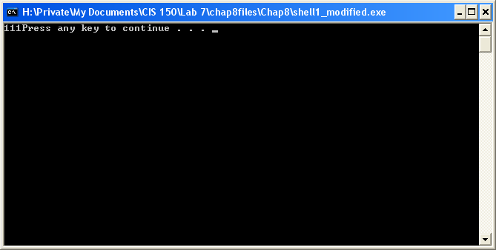

This is what I expected to occur. Since it is an automatic variable, the data that is held in memory will terminate at the end of the function that it is in.

Lesson 8-3:

Exercise 4:

// Program Convert converts a temperature in Fahrenheit to
// Celsius or a temperature in Celsius to Fahrenheit
// depending on whether the user enters an F or a C..

#include <iostream>
using namespace std;

int ConvertedTemp(int, char);

int main ()
{
char letter; // Place to store input letter
int tempIn; // Temperature to be converted

cout << "Input Menu" << endl << endl;
cout << "F: Convert from Fahrenheit to Celsius" << endl;
cout << "C: Convert from Celsius to Fahrenheit" << endl;
cout << "Q: Quit" << endl;
cout << "Type a C, F, or Q; then press return." << endl;

cin >> letter;
while (letter != 'Q')
{
cout << " Type an integer number, and press return."
<< endl;
cin >> tempIn;

if (letter == 'F')
cout << "Fahrenheit to Celsius" << endl;
else
cout << "Celsius to Fahrenheit" << endl;
cout << "Temperature to convert: " << tempIn
<< endl;
cout << "Converted temperature: "
<< ConvertedTemp(tempIn, letter)
<< endl << endl;
cout << "Type a C, F, or Q; then press return."
<< endl;

cin >> letter;
}
return 0;
}

// *******************************************

un (int tempIn, char letter)
{
if (letter == 'C')
return (9 * tempIn / 5) + 32;
else
return 5 * (tempIn - 32) / 9;
}
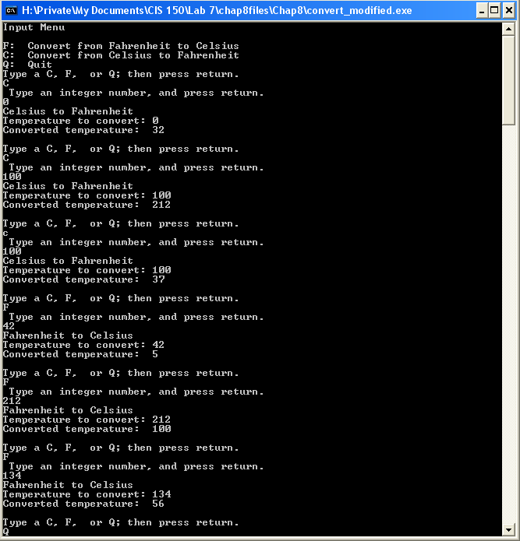

Exercise 7:

Lesson 8-4: Test Plan

Exercise 1:

Reason for Test Case | Input Values | Expected Output | Observed Output
Tests options with “known” output | C, 0 | 32 | 32
Tests options with “known” output | C, 100 | 212 | 212
Tests options with “known” output | F, 212 | 100 | 100
Tests options with “known” output | F, 32 | 0 | 0
Tests options with unexpected input that user may put in | c, 0 | 32 | -17
Tests options with unexpected input that user may put in | f, 32 | 0 | 0
Tests options with unexpected input | W | N/A | -17
Tests last option to quit | Q | Terminates | Terminates

As can be seen, the code under the function int ConvertedTemp only assumed for a converting value of literally “C”. If it was not a capitalized C, it would automatically refer to the next equation to compute the converted temperature.

Lesson 8-5: Debugging

Exercise 1:

